APC0294 ABL Data Report – Summer RV Survey 2025

Objectives – As Per the Work Plan Agreement
- Extract and quantify 88 eDNA samples.
- Develop metabarcoding libraries for COI-1 and 12S for a total of 2 libraries.
- Sequence COI and 12S libraries on the MiSeq.
- Provide raw sequencing data and corresponding sample index information.
- Provide ABL Report upon completion of the project.

1. Sample Extraction & Quantification
There were 88 glass fiber filters provided to ABL in SmithRoot casings (self-preserving). This collection consisted of 71 Samples and 17 Field Blanks, sampled from 34 different stations in the summer and fall of 2025 (Table 1).
All samples were extracted using the Qiagen DNeasy Blood and Tissue Kit (240) for the QIAcube Connect according to ABL’s modified eDNA extraction protocol. The sample filters were cut in half and digested in the Qiagen Lyse and Spin Baskets. Each set of extractions consisted of 11 samples and one Extraction Negative (ENEG), which produced a total of eight ENEGs. All extracted samples, Field Blanks, and ENEGs were quantified using the dsDNA High Sensitivity Assay Kit (ThermoFisher) for the Qubit 4 Fluorometer.
The eDNA concentrations were, on average, quite low. These ranged from 0.11 ng/µL (BBL_07) to 2.77 ng/µL (Site 230, Replicate 1). The stations with the lowest average eDNA concentrations included 186, 188, and 189; whereas stations 230 and 1012 had the highest observed eDNA concentrations (Table 1). All ENEGs had DNA concentrations that were below quantifiable limits (BQL) for the Qubit Fluorometer, and considered to be 0 ng/µL. Most of the Field Blanks also had DNA concentrations below quantifiable limits, with the exception of BLANK2 (NEC25-FB641) and BLANK5 (GUL25-FB668) (Table 1).

Table 1: The number of eDNA filter samples processed from each station, collection dates, and average eDNA concentration of samples and field blanks by station. BQL = below quantifiable limits.
Station | Date Collected | No. of Replicates | Aver. eDNA Conc. (ng/µL) | Field Blank (Yes/No) | Field Blank eDNA Conc. (ng/µL)
4 | 30-Jul-25 | 2 | 0.52 | Yes | BQL
6 | 28-Jul-25 | 2 | 0.77 | No | NA
7 | 28-Jul-25 | 2 | 0.76 | Yes | BQL
61 | 03-Aug-25 | 2 | 1.14 | Yes | BQL
64 | 26-Jul-25 | 2 | 0.66 | Yes | BQL
111 | 05-Aug-25 | 2 | 0.90 | Yes | BQL
114 | 22-Jul-25 | 2 | 0.44 | Yes | BQL
117 | 21-Jul-25 | 2 | 0.83 | No | NA
121 | 21-Jul-25 | 2 | 0.45 | Yes | BQL
125 | 20-Jul-25 | 2 | 0.35 | Yes | BQL
127 | 21-Jul-25 | 2 | 0.69 | No | NA
133 | 20-Jul-25 | 2 | 0.35 | No | NA
159 | 16-Jul-25 | 2 | 1.44 | Yes* | BQL
172 | 08-Jul-25 | 2 | 1.04 | No | NA
186 | 08-Jul-25 | 2 | 0.13 | Yes | BQL
188 | 08-Jul-25 | 2 | 0.17 | No | NA
189 | 06-Jul-25 | 2 | 0.20 | Yes | BQL
215 | 04-Jul-25 | 2 | 1.74 | No | NA
216 | 04-Jul-25 | 2 | 1.52 | No | NA
220 | 03-Jul-25 | 2 | 1.72 | No | NA
229 | 04-Jul-25 | 2 | 1.60 | Yes | BQL
230 | 04-Jul-25 | 2 | 2.52 | Yes | BQL
1012 | 03-Jul-25 | 2 | 2.19 | Yes | BQL
BBL_07 | 03-Oct-25 | 1 | 0.11 | No | NA
GUL_01 | 08-Oct-25 | 2 | 0.51 | No | NA
GUL_02 | 09-Oct-25 | 2 | 0.37 | No | NA
GUL_03 | 09-Oct-25 | 3 | 0.32 | No | NA
GUL_04 | 09-Oct-25 | 3 | 0.33 | Yes | 0.43
NEC_01 | 02-Oct-25 | 2 | 1.23 | No | NA
NEC_02 | 03-Oct-25 | 2 | 0.62 | No | NA
NEC_03 | 03-Oct-25 | 2 | 0.43 | No | NA
NEC_04 | 03-Oct-25 | 2 | 0.60 | No | NA
NEC_05 | 03-Oct-25 | 2 | 1.06 | No | NA
NEC_06 | 03-Oct-25 | 2 | 0.94 | No | NA
NEC_07 | 03-Oct-25 | 2 | 0.97 | Yes | 0.08
*Two Field Blanks were processed for this station.

2. Development of COI and 12S metabarcoding libraries
The loci used for metabarcoding were:
- COI-1:
  - mICOIintF / jgHCO2198 (Lacoursière‐Roussel et al. (2018))
    - mlCOIlintF (Leray et al. (2013))
      - Sequence: GGWACWGGWTGAACWGTWTAYCCYCC
    - jgHCO2198 (Geller et al. (2013))
      - Sequence: ACTTTCGTTCTTGATYRA
- 12S:
  - 12S_248F_RADS_For / Mifish_UR_Miya (He et al. (2023))
    - 12S_248F_RADS_For (He et al. (2022))
      - Sequence: CGTGCCAGCCACCGCGGTT
    - Mifish_UR_Miya (Miya et al. (2015))
      - Sequence: CATAGTGGGGTATCTAATCCCAGTTTG

The eDNA samples were randomized prior to the PCR reactions to avoid bias and plated to a 96-well LoBind plate according to the randomized sample number. PCR reactions were performed with three replicates per sample and a PCR negative (PNEG). The PCR replicates were pooled and screened on the 4200 TapeStation (Agilent Technologies) to confirm amplification in the samples and to ensure there was no amplification in any associated PNEG or ENEG. Amplification was low in a number of samples that were processed at the 12S locus and the PCR was repeated to try to improve the result.
Once the redos were completed and verified, the PCR product was purified using the AxyPrep Mag PCR Clean-Up Kit (Axygen), followed by quantification using the AccuClear Ultra High Sensitivity dsDNA Quantitation kit (Biotium). Purified PCR products were multiplexed with equal amounts per sample when possible, with a target input of 50 ng/sample (in 10 µL) for COI and 25 ng/sample (in 20 µL) for 12S libraries. For samples with very low DNA (such as Field Blanks and Extraction Negatives), a maximum of 10 µL was added to avoid diluting the final library concentration.
The multiplexed libraries were purified using the AxyPrep reagent, then quantified using the NEBNext Library Quant Kit for Illumina (New England Biolabs) on the QuantStudio 7 Flex (Applied Biosystems). Two libraries were developed, one library for each target, each with 96 randomly assigned samples and controls.

3. COI and 12S Library Sequencing on the MiSeq
Both libraries were sequenced using the MiSeq platform (Illumina). The MiSeq v3 Reagent Kit (600-cycle) was used for the COI-1 library, while the v2 kit (500-cycle) was used for the 12S library.
The COI-1 library was prepared to a final concentration of 13 pM, with a 15% PhiX spike-in (13pM). The run metrics looked acceptable and were within optimal ranges for the v3 kit chemistry (Table 2, Appendix 1). For the first read the Intensity, Clusters PF, and % Aligned looked really good and were fairly consistent across surfaces of the flow cell. For the second read, however, the quality of the reads dropped and the % PhiX Aligned was zero across most of the cells. Also, overall the raw density was greater than the actual density passing filter, suggesting there may still be some over-clustering. This was confirmed by consulting Illumina Tech Services. For future runs it was recommended that the input concentration of the COI-1 library be reduced further to improve the quality metrics. Despite this, the Indexing looked fairly even across samples with 81.3% Reads Identified (PF) (min. = 0.0032, max. = 1.5218, CV = 0.6425).
Table 2. Summary of sequencing run parameters and data output quality metrics.
Library/Run | MiSeq Reagent Kit/Chemistry | Library Input | PhiX Spike-in (%) | % > Q30 | Cluster Density (K/mm²) | Clusters PF (%) | Data Yield (Gb)
APC0294 COI-1 R1 | v3 (600-cycle)  PE | 13pM | 15 | 77.88 | 1113 ± 25 | 84.01 ± 1.72 | 14.83
APC0294 12S R1 | v2 (500-cycle)  PE | 7pM | 20 | 79.83 | 765 ± 23 | 91.76 ± 1.77 | 7.75
PE = paired end

The 12S (ribosomal RNA) library was prepared to a final concentration of 7 pM with a 20% PhiX spike-in (also at a concentration of 7 pM). In general the sequencing run metrics looked good and were within optimal ranges for the MiSeq Reagent kit version and chemistry (Table 2). The quality scores were a little low and inconsistent throughout the run, as seen in the Q-Score Distribution Map (Figure 1). This could be a factor of low amplification observed for samples with the 12S assay. However, the % >Q30 was still within the acceptable range for the kit chemistry (≥75%).

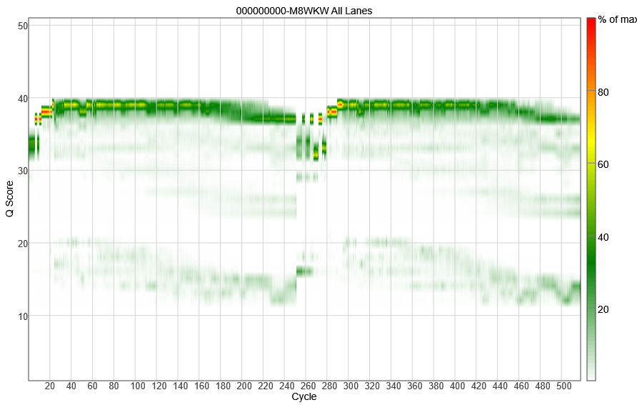
Figure 1. Heat map of the Quality Score distributions for the 12S Library MiSeq run. Note the frequent drops in Q Scores across cycles.

The indexing looked decent for the run, with 75.39% of Reads Identified (Pass Filter). The percent of reads pass filter for each index was not always consistent across samples, with some sample index reads as low as the Field Blanks (min. = 0.0057; max. = 1.9768; CV = 0.8817). The Extraction Negatives and Field Blanks consistently had low reads and were close to zero, as expected.

4. Provide Raw Sequencing Data
The sequence data for each of the COI-1 and 12S library sequencing runs were retrieved from the MiSeq. The sequence data (.fasta) and metadata were uploaded to the shared Teams project page “Summer RV Survey”.

Conclusions

Extract & quantify 140 eDNA
- 88 samples (SmithRoot filters, self-preserving) from 34 different stations were provided to the ABL.
- All samples were extracted from half-filter using Qiagen’s DNeasy Blood and Tissue kit for the QIAcube Connect, with 8 Extraction Negatives being generated. The DNA was quantified using the Qubit dsDNA HS Assay for the Qubit v4.

Develop libraries for COI-1 and 12S and sequence on the MiSeq
- One library was produced for COI-1 and 12S (with 96 randomized samples each, including ENEGs), for a total of 2 libraries.
- The COI-1 library was successfully sequenced on the MiSeq.
- The 12S library was also successfully sequenced on the MiSeq.
- There were issues with the % PhiX aligned for the COI-1 MiSeq run; however, the sequencing output values were within optimal ranges for both libraries.
- The raw sequencing data for the COI-1 and 12S libraries were uploaded to the Teams project page, “Summer RV Survey”.

References

Geller, J., Meyer, C., Parker, M., and Hawk, H. (2013). Redesign of PCR primers for mitochondrial cytochrome c oxidase subunit I for marine invertebrates and application in all-taxa biotic surveys. Molecular Ecology Resources 13, 851-861.

He, X., Jeffery, N.W., Stanley, R.R.E., Hamilton, L.C., Rubidge, E.M., and Abbott, C.L. (2023). eDNA metabarcoding enriches traditional trawl survey data for monitoring biodiversity in the marine environment. ICES Journal of Marine Science 80, 1529-1538.

He, X., Stanley, R.R.E., Rubidge, E.M., Jeffery, N.W., Hamilton, L.C., Westfall, K.M., Gilmore, S.R., Roux, L-M.D., Gale, K.S.P., Heaslip, S.G., et al. (2022). Fish community surveys in eelgrass beds using both eDNA metabarcoding and seining: implications for biodiversity monitoring in the coastal zone. Canadian Journal of Fisheries and Aquatic Sciences 79, 1335–1346.

Knudsen, S.W., Ebert, R.B., Hesselsøe, M., Kuntke, F., Hassingboe, J., Mortensen, P.B., Thomsen, P.F., Sigsgaard, E.E., Hansen, B.K., Nielsen, E.E., and Møller, P.R. (2019). Species-specific detection and quantification of environmental DNA from marine fishes in the Baltic Sea. Journal of Experimental Marine Biology and Ecology 510, 31-45. https://doi.org/10.1016/j.jembe.2018.09.004.

Lacoursière-Roussel, A., Howland, K., Normandeau, E., Grey, E.K., Archambault, P., Deiner, K., Lodge, D.M., Hernandez, C., Leduc, N., and Bernatchez, L. (2018). eDNA metabarcoding as a new surveillance approach for coastal Arctic biodiversity. Ecology and Evolution 8, 7763-7777.

Miya, M., Sato, Y., Fukunaga, T., Sado, T., Poulsen, J.Y., Sato, K., Minamoto, T., Yamamoto, S., Yamanaka, H., Araki, H., et al. (2015). MiFish, a set of universal PCR primers for metabarcoding environmental DNA from fishes: detection of more than 230 subtropical marine species. Royal Society Open Science 2, 150088.

Appendices

Appendix 1. The optimal sequencing output ranges for the types of reagent kits used.
MiSeq Reagent Kit | Read Length | Output | Reads Passing Filter | % Pass Filter | Cluster Density (k/mm²⁾ | % > Q30
v2 (500-cycle) | 2 x 250 bp | 7.5-8.5 Gb | 24-30 M | 85-95% | 865-965* | 75%
v3 (600-cycle) | 2 x 300 bp | 13.2-15 Gb | 44-50 M | 80-90% | 1200-1400* | 70%
*These are optimal cluster densities for well-balanced libraries. For low diversity libraries, such as COI and 12S, a target 30-40% below the optimal cluster densities was attempted.

